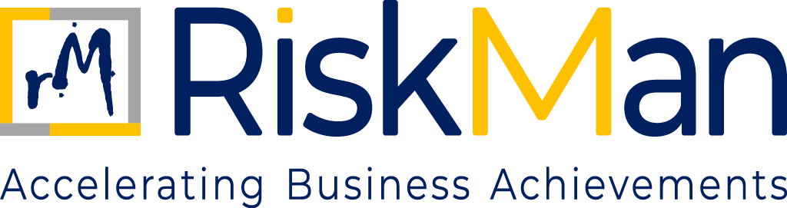
RISK MANAGEMENT POLICY
TABLE OF CONTENTS
RISK MANAGEMENT POLICY

- Objective…………………………………………………………………………………………..…………………………………………………….3
- Scope and Applicability……………………………………………………………………..……………………………….......................3
- Risk Management Approach…………………………………………………………..……..………………………………………………..3
- Risk Governance and Oversight……………………………………..……………………………..............................................4
- Risk Appetite…………………………………………………………..……………………………………………………………………………....5
- Key Risk Area……………………………………………………………………………………………………………………………………………4
- Risk Identification and Assessment………………………………………………………………………………………………………….3
- Risk Mitigation and Management……………………………………………………………………………………………………………3
- Escalation and Issue Management………………………………………………………………………………………………………….4
- Incidents and Learning……………………………………………………………………………………………………………………………3
- Integration with other Policies………………………………………………………………………………………………………………..3
- Training and Risk Awareness……...…………………………………………………………………………………………………………..3
RISK MANAGEMENT POLICY
- OBJECTIVE

The objective of this Risk Management Policy is to establish a structured and proportionate framework through which RiskMan Consulting LLP (“RiskMan” or “the Firm”) identifies, evaluates, and manages risks arising from its professional services, client engagements, people, operations, and reputation.

This Policy is designed to:
- Support informed and responsible decision-making
- Protect the Firm’s professional credibility and reputation
- Ensure ethical and compliant conduct of assurance and advisory engagements
- Embed risk awareness into governance, client acceptance, and engagement delivery processes.
- SCOPE AND APPLICABILITY

This policy applies to all individuals and entities associated with RiskMan Consulting LLP. It covers all employees, including those who are permanent, contractual, or interns, as well as partners, consultants, and associates who are professionally engaged with the Firm. Additionally, the policy extends to clients, suppliers, vendors, and any other third-party stakeholders who interact with or are connected to the operations and business activities of RiskMan in any capacity.

- RISK MANAGEMENT APPROACH
RiskMan recognises that, as a professional services firm:
- Primary risks arise from judgment, advice, people, and reputation, rather than physical assets; and
- Effective risk management is achieved through strong governance, disciplined client acceptance, quality delivery, and ethical conduct.
The Firm adopts a principles-based, engagement-centric, and governance-driven approach to risk management.
- RISK GOVERNANCE AND OVERSIGHT

  - Oversight by Partners: The Partners have ultimate responsibility for:
- Approving the Firm’s risk management framework
- Defining the Firm’s overall risk appetite
- Overseeing material engagement, reputational, and compliance risks
- Ensuring that risk considerations are embedded in strategic and operational decisions

  - Management and Engagement Leadership: Senior management and engagement leaders are responsible for:
- Identifying and managing risks within their respective areas and engagements
- Ensuring compliance with Firm policies
- Escalating material risks to the Partners in a timely manner
- RISK APPETITE

RiskMan’s risk appetite reflects its commitment to:
- High ethical and professional standards
- Compliance with applicable laws, professional requirements, and Global Standards
- Protection of client trust and Firm reputation.
The Firm adopts a low tolerance approach towards risks that may undermine its ethical standards, professional integrity, or credibility, including:
- Unethical, unlawful, or non-compliant behaviour
- Actual / potential / perceived conflicts of interest that are not appropriately identified and disclosed
- Any compromise of independence, objectivity, or professional judgment
- Engagements or activities that expose the Firm to unacceptable reputational, regulatory, or legal risk.
- KEY RISK AREAS
RiskMan’s risk management focus includes, but is not limited to, the following areas:

6.1 Engagement and Client Risk: Risks arising from:
- Client integrity, reputation, or conduct
- Unclear or inappropriate engagement scope
- Unrealistic client expectations
- Misalignment between client needs and Firm capability
These risks are primarily managed through Client Acceptance & Continuance, engagement scoping, and Partner oversight.

6.2 Professional Judgment and Quality Risk: Risks arising from:
- Flawed professional judgment
- Inadequate supervision or review
- Insufficient competence or experience
- Deviation from professional standards
These risks are managed through quality assurance processes, review mechanisms, and competency requirements.

6.3 Independence and Conflict Risk: Risks arising from:
- Conflicts of interest
- Financial, personal, or business relationships
- Provision of multiple services that impair objectivity
These risks are managed through the Firm’s Conflict of Interest and Independence policies.
6.4 Compliance and Regulatory Risk: Risks arising from:
- Non-compliance with laws, regulations, or professional standards
- Contractual breaches
- Inadequate regulatory awareness
These risks are managed through the Firm’s Compliance Management framework and policy controls.

6.5 Information, Data, and Cyber Risk: Risks relating to:
- Confidentiality of client information
- Personal data protection
- Cyber security incidents
These risks are managed through Information Security, Data Privacy, and Cyber Security policies.

6.6 Reputational Risk: Risks that may adversely affect the Firm’s credibility, brand, or stakeholder trust, including:
- Association with inappropriate clients
- Unethical conduct
- Poor quality service delivery.
Reputational risk is treated as an overarching consideration across all decisions.
- RISK IDENTIFICATION AND ASSESSMENT
Risk identification and assessment occur primarily through:
- Client acceptance and continuance reviews
- Engagement planning and scoping discussions
- Management and Partner reviews
- Incident analysis and lessons learned
- Monitoring of regulatory and market developments
Risk assessment is qualitative and judgment-based, reflecting the nature of consulting activities.

- RISK MITIGATION AND MANAGEMENT
Risk mitigation measures may include:
- Declining or discontinuing engagements
- Modifying engagement scope or delivery approach
- Implementing additional review or oversight
- Deploying experienced personnel
- Strengthening contractual terms
Mitigation actions shall be proportionate to the nature and severity of the identified risk.
- ESCALATION AND ISSUE MANAGEMENT
Material risks, concerns, or incidents shall be:
- Escalated promptly to senior management or Partners; and
- Addressed through appropriate corrective actions.
Issues that cannot be mitigated within acceptable risk tolerance shall be escalated for Partner decision.
- INCIDENTS AND LEARNINGS
Significant incidents, including Client disputes, Regulatory issues, Quality failures shall be reviewed to Identify root causes and Incorporate lessons learned into Firm practices and policies.
- INTEGRATION WITH OTHER POLICIES
This Policy operates in conjunction with, and is supported by:
- Corporate Governance Policy
- Client Acceptance & Continuance Policy
- Quality Assurance & Independence Policy
- Compliance Management Policy
- Information security and Data Privacy Policy
Risk management is embedded across the Firm’s policy framework.
- TRAINING AND RISK AWARENESS
The Firm promotes ethical awareness through Induction programmes, Periodic communication, and Training initiatives, Partner and management communication, and Engagement-level discussions as appropriate.
Personnel are expected to exercise professional judgment and raise concerns when risks are identified.

